The Post Office (20th April – 1st May)
This fortnight we would be working on the theme of the Post Office and the work of the Postman or Postwoman. As always, the work listed here is a menu – pick and choose as you wish.
Maths  For both classes, please emphasise that real coins must be used. Children may say when making up 5c, for example, that we can use a 2c and a 3c without realising that there is no 3c coin. Also, children may count coins instead of value of coins when adding money so emphasise the value of a coin if it is more than 1c. | - Work on the concept of money. What is the price of a stamp? €1!  - What does a €1 coin look like? What colours are on the coin? Put it under a sheet of paper and use some crayons to do coin rubbings.  - If a stamp costs €1, how much for 3? How much change will I get from €5? Etc.  - Use Mathematical language to discuss letters and packages – is it too heavy? Is the envelope long enough? Etc.
 | - Junior Infants:  - If a stamp costs 5c/4c/3c/ etc what are the coins I can use to make us that amount?  - If a stamp costs 3c(etc.) and I give the shopkeeper 5c, how much will I get back in change?  - Bust at Maths book P113-120  - Figure It Out P63 and 64  - For extra activities and support look at http://my.cjfallon.ie  - Junior Infants work up to the value of 5c |  | - Senior Infants:  - If a stamp costs 10c/8c/6c/ etc what are the coins I can use to make us that amount?  - If a stamp costs 7c(etc.) and I give the shopkeeper 10c, how much will I get back in change?  - Bust at Maths book P104-109  - Figure It Out P47-49 and P59  - For extra activities and support look at http://my.cjfallon.ie  - Senior Infants work up to the value of 10c  - Master Your Maths Weeks 25 and 26
English | - Write a letter!! This fortnight we would be working on writing a letter to our family. If you want to send a picture of any letters I will reply!! I’d love to read all about what you did for your Easter holidays.  - I will post some more readers on Dojo along with a new list of tricky words
 | - Junior Infants:  - Just Phonics P72-77  - Sounds Make Words P26 – P30  - Reading – “Splash” can be accessed on the Folens website along with the activity book. (I will put on Dojo also)  - There are also two books on the website that repeat the new words learned in “The Lost Ball” called “Teddy is Lost” and “The Big Box”. These are great for revision of words.  - As we have worked on all the letters in our handwriting, give your child the opportunity to write every day – a short sentence, the shopping list, news etc. |  | - Senior Infants  - Just Phonics P52-60  - Reading – “Stop That Dog” can be accessed online on the Folens website along with the activity book. (I will put on Dojo also)  - There are also two books on the website that repeat the new words learned in “What a Mess” called “I’m Not Scared” and “Are You Kitty”. These are great for revision of words.  - As we have worked on all the capital letters in our handwriting, give your child the opportunity to write every day – approximately 3 sentences.
Gaeilge | 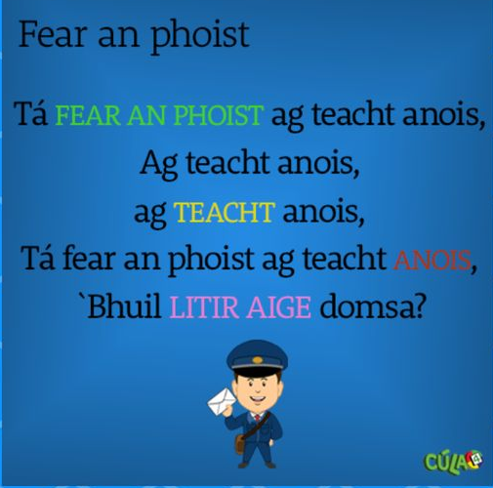  The Postman is coming now, is coming now, is coming now  The Postman is coming now, have you a letter for me?
 | Irish  Postman  Letter  Thug sé litir dom.  Bronntanas  Scríobh mé ..  Stampa  Oifig an Phoist | English  Fear an Phoist  Litir  He gave me a letter.  Present  I wrote  Stamp  Post office |  | Pronunciation  Far on fwisht  Litter  Hug shay litter dum.  Brun tennis  Skreeve may  Stompa  Iffig on fwisht
P.E. | - Make up a dance routine to your favourite song  - Practise throwing and catching a ball  - Build a fort  - Cycle your bike  - There are loads of activities on www.gonoodle.com You can register for free.  - Schedule plenty of movement breaks and physical activities throughout the day  - Take as many chances to get outside and play as possible
S.E.S.E.  (History, Geography and Science) | - Learn your own address and practise writing it – maybe keep an eye on the post as it comes to see your address on envelopes  - Learn what an Eircode is and display it somewhere prominent at home.  - Have a look at a map and find where you live  - Talk about the work of those in the post office  - Tell your child where the Post Office used be located in Ballydesmond (Unfortunately for the moment I can’t suggest showing them!! – This will be part of our walking tour when we get back to school!)  - Journey of a letter – Ireland  https://www.youtube.com/watch?v=L7YlG__1zfY  - Lenny the Letter – Not in Ireland but has a catchy song!!!  https://www.youtube.com/watch?v=1PSBQJBkpEY
Art | - Make a card to post to your friend or family member  - Design your own uniform for a postal worker  - Design a wrapping paper for your friend’s birthday present  - Design and colour your own personalised stamp!  - Colour by number sheets on Twinkl
Music | - Postman Pete Song https://www.youtube.com/watch?v=VM4Bv36POHc
Religion | - Say a special prayer each night for all our frontline workers. You might make up your own one or use this one as it is part of their curriculum.  Prayer to our Guardian Angel  Angel sent by God to guide me(them),  be my(their) light and walk beside me(them);  be my(their) guardian and protect me(them);  on the(their) paths of life direct me(them).  Amen.  - Research a bible story each week, e.g. The Story of Creation, Jesus Clams a Storm, The Loaves and the Fishes, The Woman at the Well, Jesus Walks on Water, The Story of the Blind Man etc.
Extra | - Oral Language – Talk about all the work that is done in the Post Office e.g. TV licence renewal, weighing packages, paying bills etc.  - Wave at your Postman in the morning and give him a big thumbs up. He is working very hard and is taking care of lots of people.  - Have a look on Twinkl for many more activities related to the theme of the Post Office or other themes that may interest you and your child  - Watch Postman Pat!!  - Have fun!!!

